**FSD ASSIGNMENT - 1**

**Exercise 1: Basic HTML5 Structure**

Objective: Understand the basic structure of an HTML5 document.

Task:

Create a webpage with the following:

● A title “My First HTML Page”

● A heading (<h1>) with your name

● A paragraph (<p>) describing your hobbies

● A horizontal line and a line break

**Code :-**

<title>My first HTML web page </title>

<h1>Nithin U</h1>

<p>My Hobbies are <br>

<hr>

reading Books

<hr>

Playing cricket

<hr>

travelling

<hr>

watching movies

<hr>

</p>

**Output :-**

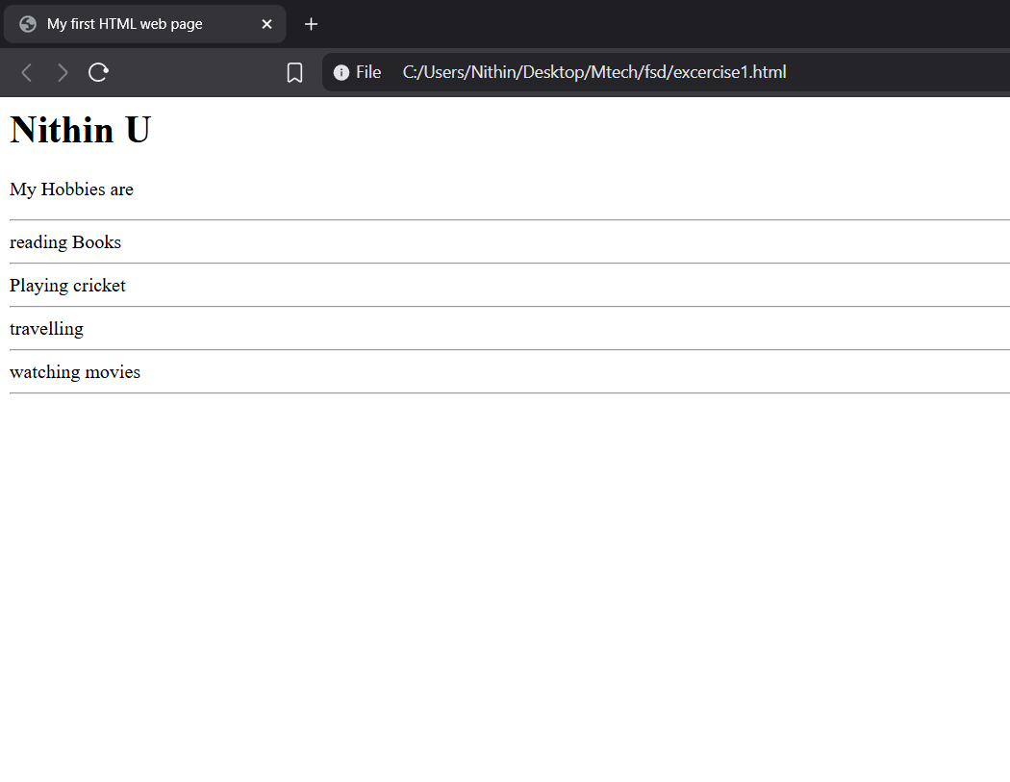

**Exercise 2: Use of Lists and Links**

Objective: Practice using different list types and hyperlinks.

Task:

Create a page that includes:

● An unordered list of your favorite fruits

● An ordered list of top 3 movies

● A hyperlink to your favorite website (open in a new tab)

**Code :-**

<ul>

<h1>My favorite fruits list</h1>

<li>orange</li>

<li>banana</li>

<li>apple</li>

<li>papaya</li>

</ul>

<hr>

<ol>

<h1>List of top 3 movies</h1>

<li>Batman</li>

<li>Batman Begins</li>

<li>Batman rises Again</li>

</ol>

<h1>Hyper link to my favorite website is below</h1>

<a href="https://noomoagency.com/"><h3>Favorite Website for it's DESIGN</h3></a>

**Output :-**

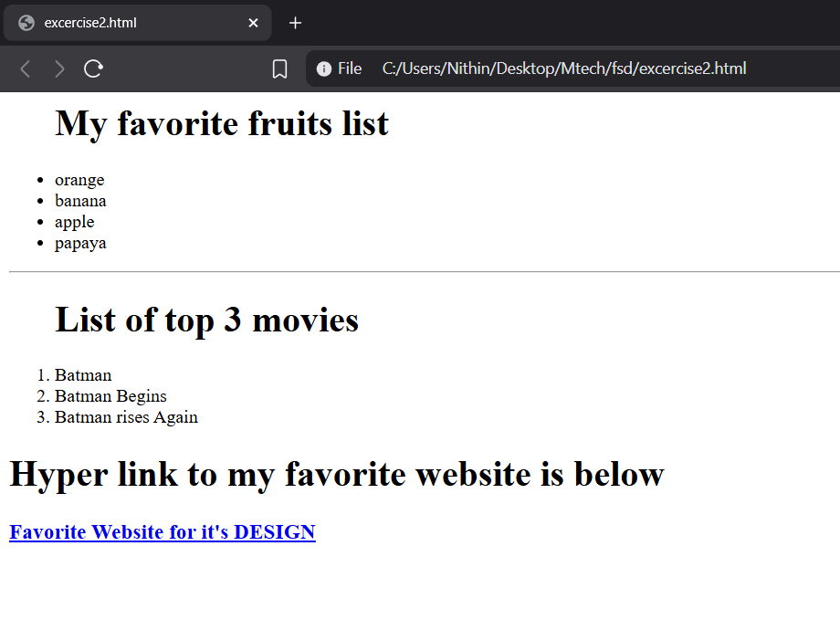

**Exercise 3: Adding Images and Tables**

Objective: Insert images and create tables using HTML.

Task:

● Insert an image using the <img> tag (use a placeholder URL or

local image)

● Create a table with 3 rows and 3 columns showing:

○ Student Name, Age, and Favorite Subject

**Code :-**

<!DOCTYPE html>

<html lang="en">

<head>

<meta charset="UTF-8">

<meta name="viewport" content="width=device-width, initial-scale=1.0">

<title>Image and table</title>

</head>

<style>

table, th, td {

border:1px solid black;

}

</style>

<body>

<h1>Car Image </h1>

<img src="https://www.usnews.com/object/image/00000191-d821-d8b8-adf7-f97944b10000/chevrolet-corvette-zr1-coupe-001.jpg?update-time=1725907944302&size=responsiveGallery" alt="Website Image" >

<hr>

<br><br><br><br><br>

<table style="width:100%">

<tr>

<th>Student Name</th>

<th>Age</th>

<th>Favorite subject</th>

</tr>

<tr>

<td>Tony</td>

<td>18</td>

<td>Arthashatra</td>

</tr>

<tr>

<td>Robert</td>

<td>17</td>

<td>Vignana</td>

</tr>

<tr>

<td>Tony</td>

<td>16</td>

<td>Samaja Vignana</td>

</tr>

</table>

<br><br><br><br><br>

<br><br><br><br><br>

</body>

</html>

**Output :-**

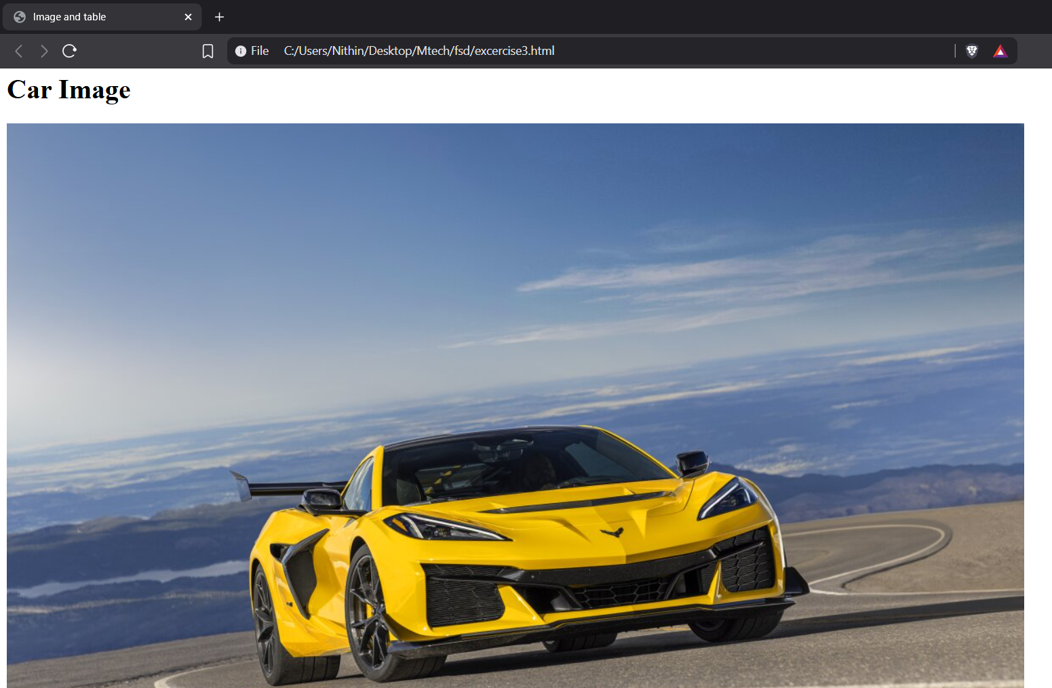

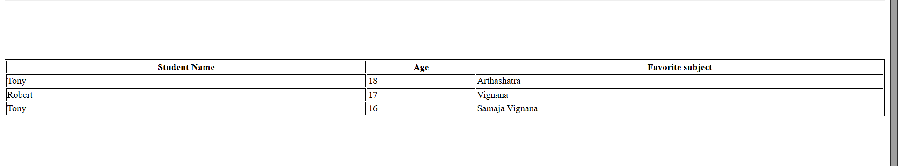

**Exercise 4: Introduction to CSS (Internal CSS)**

Objective: Apply basic styles to HTML using <style> tag.

Task:

● Create a heading styled with:

○ Background color: lightblue

○ Text color: darkblue

○ Font size: 30px

● Style a paragraph with:

○ Font family: Arial

○ Text alignment: justify

**Code :-**

<!DOCTYPE html>

<html lang="en">

<head>

<meta charset="UTF-8">

<meta name="viewport" content="width=device-width, initial-scale=1.0">

<title>Document</title>

</head>

<body>

<h1 style="color: darkblue; background-color: lightblue;">Web Page Heading</h1>

<hr>

<br><br><br><br><br>

<p style="font-family: Arial; text-align: justify; font-size: large;">

The scent of freshly brewed coffee, a comforting aroma, filled the small, sunlit kitchen. Dawn was breaking, casting a warm, golden glow across the room. A gentle breeze rustled the leaves outside, a quiet symphony of nature's awakening. The first cup of the day, a rich, dark brew, was a ritualistic pleasure, a moment of calm before the busy day began. The simple act of savoring the taste, the warmth of the cup, and the peace of the morning provided a much-needed sense of tranquility, a perfect prelude to the hustle and bustle of the day.

</p>

</body>

</html>

**Output :-**

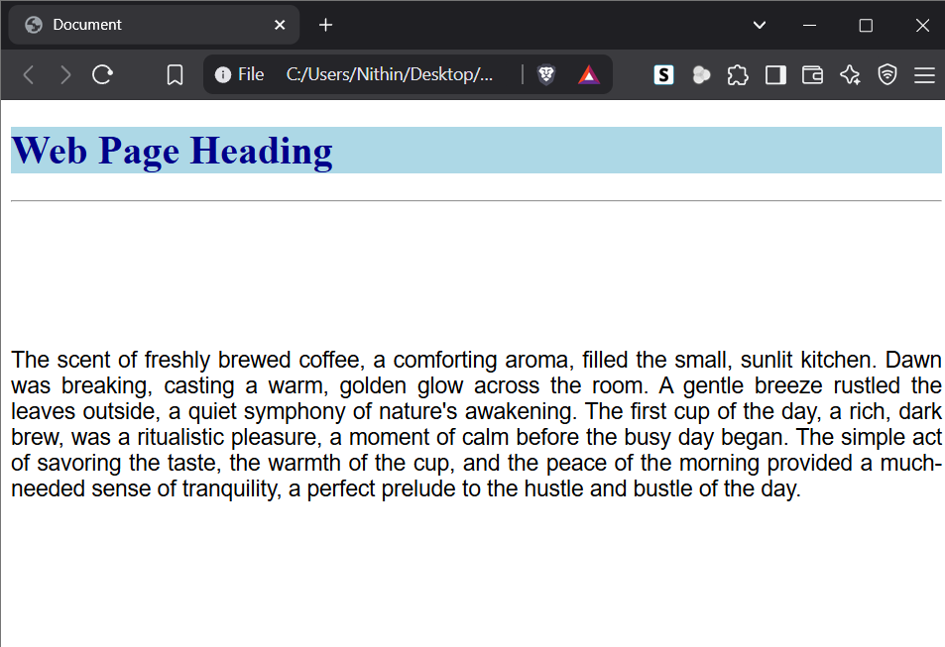

**Exercise 5: CSS Classes and IDs**

Objective: Learn to differentiate and apply CSS classes and IDs.

Task:

● Create two <div> blocks:

○ One with ID intro styled with a border and padding

○ One with class highlight styled with a yellow background

● Add text to both and observe the styles

**Code :-**

<!DOCTYPE html>

<html lang="en">

<head>

<style>

p.dotted {border-style: dotted;}

</style>

<meta charset="UTF-8">

<meta name="viewport" content="width=device-width, initial-scale=1.0">

<title>Document</title>

</head>

<body>

<div id="intro" style=" padding: 20px;">

<h1 style="color: blueviolet;"> This is the sample text in div one</h1>

</div>

<div class="highlight" style="background-color: yellow;">

<h1 style="color: red;">This is the sample text in div two</h1>

</div>

</body>

</html>

**Output :-**

